iReport & iReport Server
User Guide

1. Create JDBC 2
2. Import Query (SQL) 4
3. Add Parameter 5
4. Sorting 6
5. Cover Page 7
6. Header Details Footer 8
7. Summary Pages 9
8. Formula Column 10
9. Add Report File To Server , Save Report 11
10. Create input control 14
11. Scheduler 17
12. Output Format 18
13. Export PDF font setting 19
14. HTTP API 21
15. Disable Button on JasperServer Web Page 22
16. Add User / Roles 23
17. Set Folder Permissions 25
18. Sub-Report Setting 27
19. Font Setting 29
20. JRSA API 31
21. Excel Pivot Table 32
22. Add Excel Pivot Table 38
23. Disable "export menu" option 43
24. Backup & Restore File 44

- Create JDBC

Open iReport -> “Tools” -> “Options”
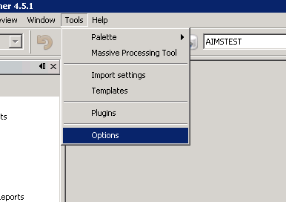

“Classpath” -> “Add JAR”
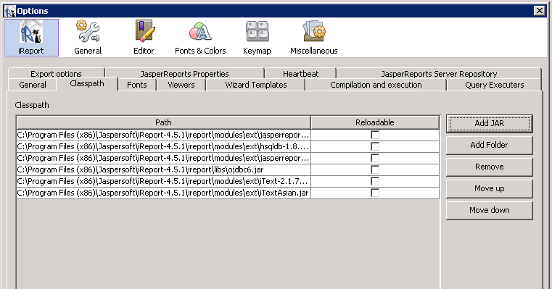
Select your oracle JDBC driver and add it
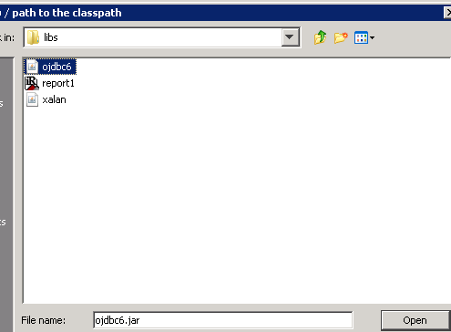

Done and click “OK”
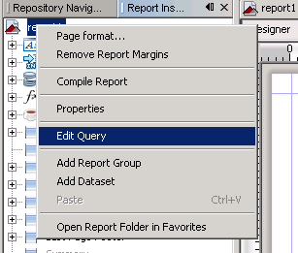
- Import Query (SQL)

Right click your report file -> “Edit Query”
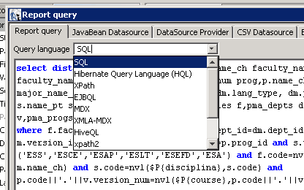

“Query Language” -> select “SQL”
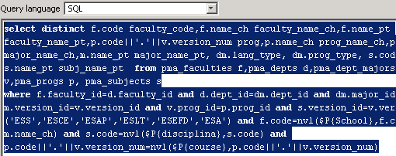

Write your SQL in below then click “OK”
- Add Parameter

Choose “Parameters” right click -> “Add Parameters”
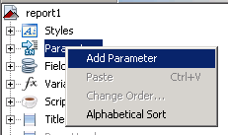

You will see a new parameters have created below , right click it and “Rename” what you want.
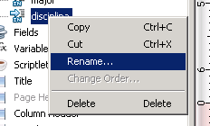
- Sorting

Right click your report file -> “Edit Query”
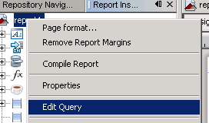

Click “Sort Options”
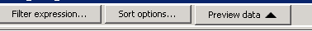

Click “Add Filed” -> select which filed what you want to sort
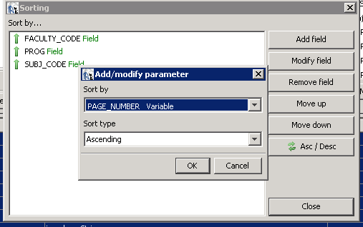

Click “OK” then done.
- Cover Page

Write something in “Title” section. Right click your report file -> “Properties”
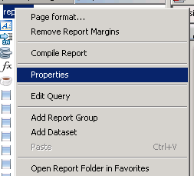

Find “Title on a new page” and turn it “True”
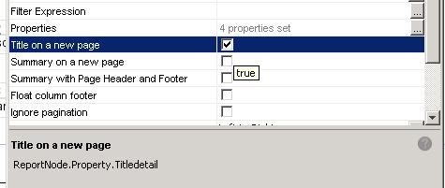

Finish.
- Header Details Footer

- Summary Pages

- Formula Column

- Add Report File To Server , Save Report

Select “Repository Navigator”
Your server Name -> Right Click “Reports” -> Add -> “Jesper Server Report”
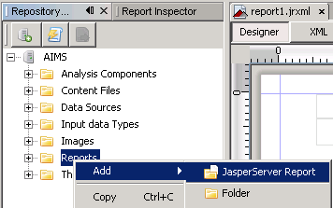

Input info. (ID is report id , Name is the name show on iReport Server) then Click “Next”
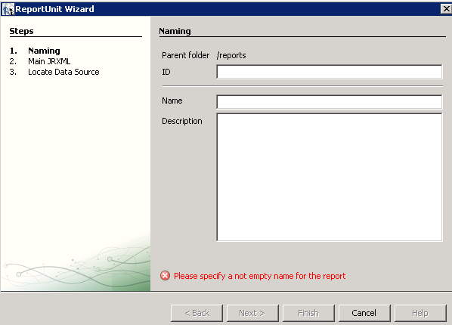
Select your report file or you can click “ Get source from current opened report ”
Then Click “Next”
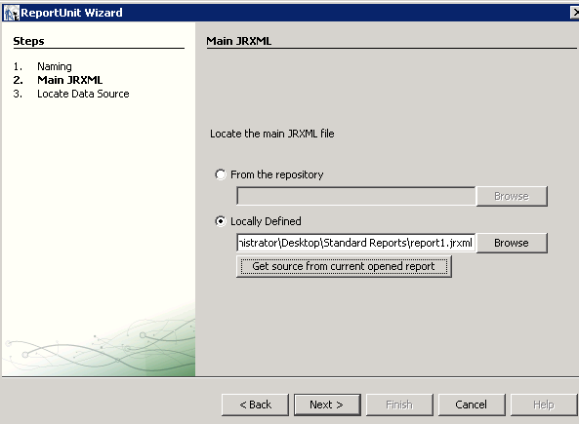

Select “From the repository” -> Select the Database path before you added.
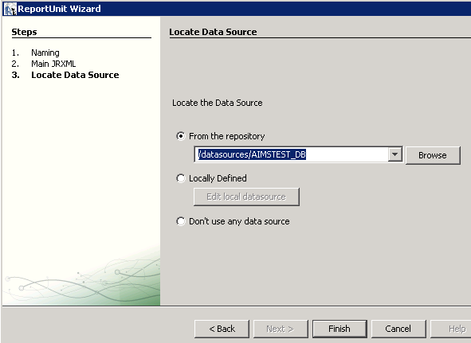
Finish
Update your report to iReport Server.
Click “Save All (Ctrl+Shift+S)”
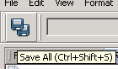

Select “Repository Navigator” -> Find your report -> right click your report html file
-> Click “Replace with current document ”
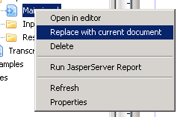

Done
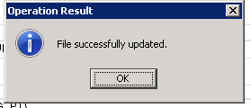
- Create input control

Login to the web and go to your report file folder , right click on your report file , click “Edit”
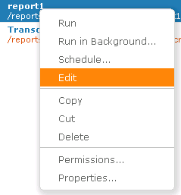

Select “Controls & Resources” then in “Input Controls” filed , click “Add Input Control…”
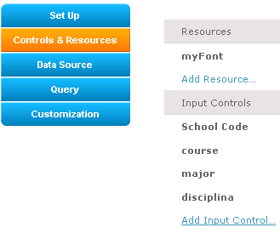

Click “Next”
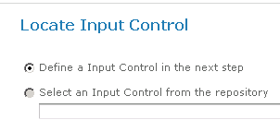
Select “Type” , filed “Prompt text” , “Parameter name” ( it must be same with your parameter name in report file ) and Input name & ID
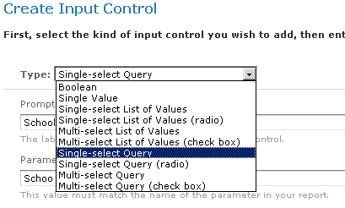

Select the option then Click “Next”
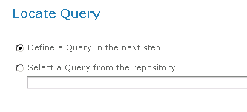

Input the empty then click “Next”.
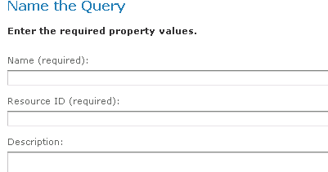
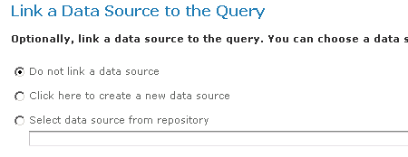

Select the Query language type and write your query.
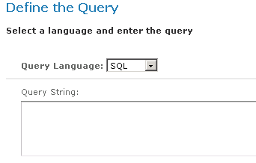

Filed the “Value Column” & “Visible Column” (is must be same with the query what you write before)
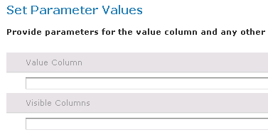

Finish.
- Scheduler

- Output Format

Output format
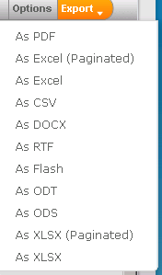
- Export PDF font setting

Select “Tools”->”Options”.
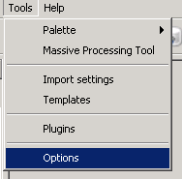

Select “Font” tab, then click “Install Font”
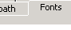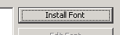

Select the font file what you want to install
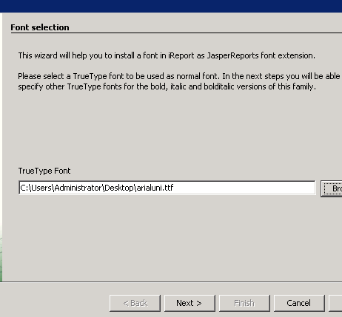
In “PDF details” Select “Identity-H (Unicode with horizontal writing)” and click “Embed this font in the PDF document”
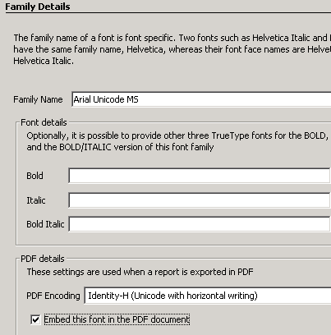

Finish.

14. HTTP API

Link to Jasper Server by web link

http://localhost:8080/jasperserver/flow.html?_flowId=viewReportFlow&standAlone=true&_flowId=viewReportFlow&ParentFolderUri=/reports/MPI_Standard_Reports&reportUnit=/reports/MPI_Standard_Reports/report1&j_username=jasperadmin&j_password=jasperadmin&School=ESEFD&disciplina=PCOS412&output=pdf

ParentFolderUri= (path of your report file document)
reportUnit= (path of you report file)
j_username = jasper login username
j_password = jasper login password

Add parameters
(your report parameter name)=(value)
Ex. School=ESEFD
“school” is the parameter in the report , “ESEFD” is a value in “school”

Output Formate
output=pdf output PDF file directly
output=xls output Excel file directly
- Disable Button on JasperServer Web Page

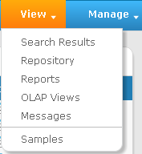

Go to your JasperReport Server folder and modify this file
(apache-tomcat/webapps/jasperserver/WEB-INF/actionModel-navigation.xml)

Manage button :
Delete <context name="main_view_mutton" test="!banUserRole">…</context>

View button :
Delete <context name="main_manage_mutton" test="checkAuthenticationRoles" testArgs="ROLE_ADMINISTRATOR">…</context>
- Add User / Roles

Add user
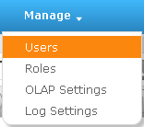

Click Add User…
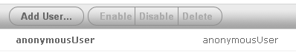

Fill the form then click “Add User”
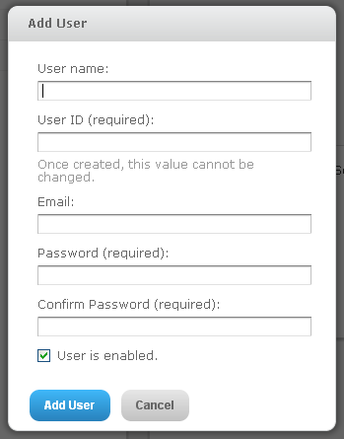
Add roles
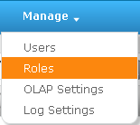

Click Add Role
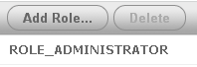

Fill the name then Click “Add Role”
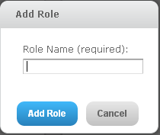
- Set Folder Permissions

Choose a folder and Right Click -> Permissions
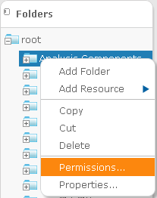

Click “View by : User” , you can set the file folder who can read/write, who can not
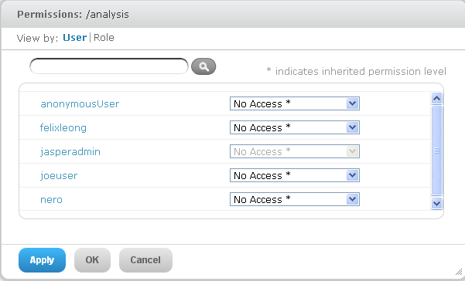
Access right
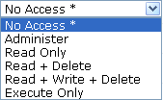

Click “View by : Role” , same as “View by : User” (Group by user)
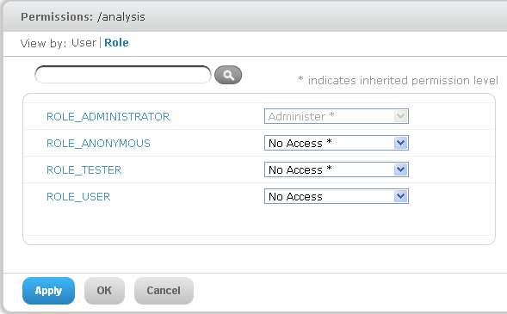
- Sub-Report Setting

Choose Subreport
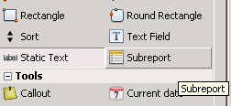

Click “Use an existinc report” then select you subreport file
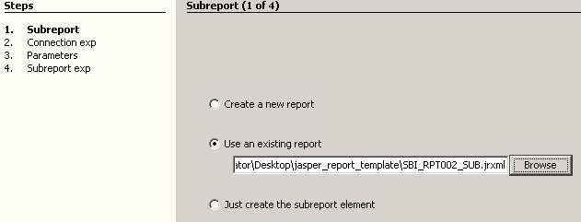

Choose “Use the same connection used to fill the master report”
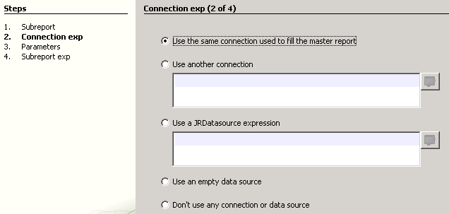
The “Parameter name” is your subreport parameter what you set before , You need to select a value which corresponding to master report value. 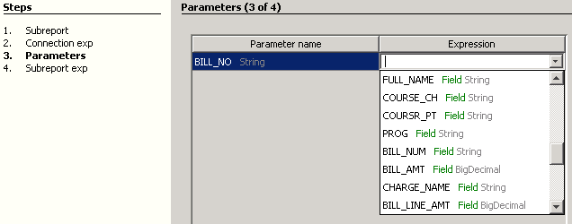

Choose “Store the directory name in a parameter”
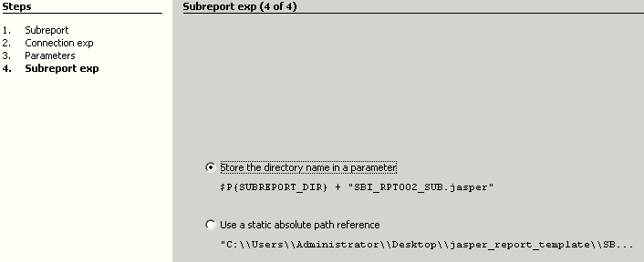

Finish !
- Font Setting

In iReport Designer Click “Tools” -> “Options”
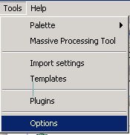

iReport -> JasperReport Properties
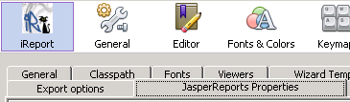

Find “net.sf.jasperreports.default.pdf.font.name” -> set to you font name which had installed in ireport.
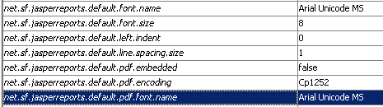
Add font file to server , right click on Resources folder , click “JAR Archive”
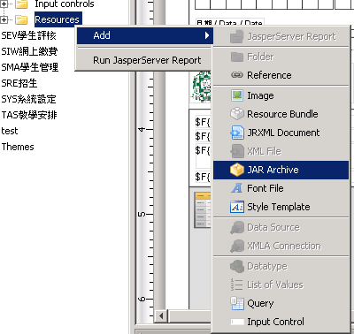

Choose you font file , you must zip it to JAR file and modify some setting file. (please see the demo file myFont.jar)
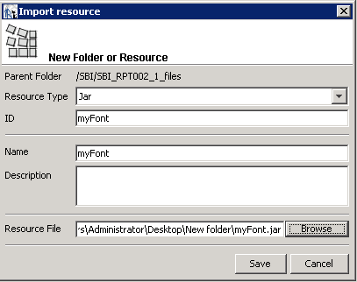

Done.
- JRSA API

http://172.25.2.85:8080/JRSA/verify?uid=jasperadmin&pwd=jasperadmin&typ=preview&receipt_num=101105457&path=/SBI/SBI_RPT001

Please set the IP to your JRSA server IP or domain name. Eg: xxx.ipm.edu.mo
Uid & pwd : please setup a new account for used this tool. Eg: jrsa
Type : preview for preview , print for print directly.
Path : the report file path.
receipt_num : it’s a parameter name , it’s must same with the report file parameter.

Source code & Demo : (Eclipse)
http://172.25.2.114:8080/jasperserver/JRSA.war

Disable Java Auto Update
 → → → → Uncheck this
And it will show a warning box, please click after please click

Pre-load JRSA Jar file
http://172.25.2.140:8080/JRSA/verify?uid=jasperadmin&pwd=jasperadmin&typ=preview&parasName=PAR_RECEIPT_ID,PAR_RECEIPT_ID2&parasValue=62015,62015&path=/SBI/SBI_RPT001

http://aimsadmrpt.ipm.edu.mo:8080/JRSA/verify?uid=jasperadmin&pwd=jasperadmin&typ=preview&parasName=PAR_RECEIPT_ID,PAR_RECEIPT_ID2&parasValue=62015,62015&path=/SBI/SBI_RPT001
- Excel Pivot Table

Download & Install “Oracle Database 11g Release 2 Client”
http://www.oracle.com/technetwork/database/enterprise-edition/downloads/112010-win32soft-098987.html

Then , Set the “TNS Service”, Click “Net Manager”
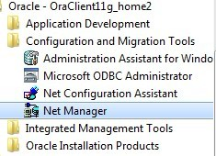

Click “Add” -> Input “orcl”.
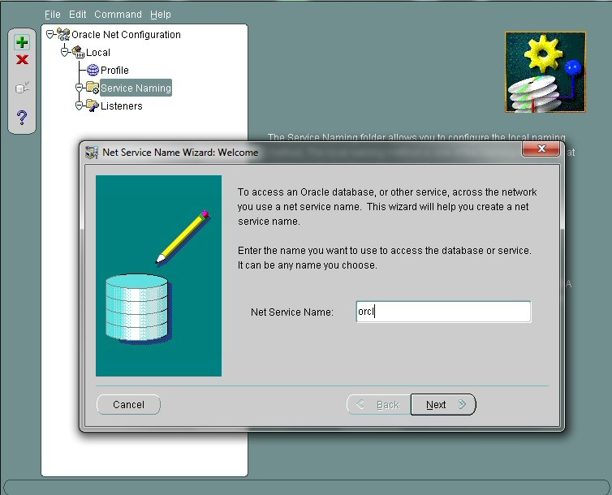
Select “TCP/IP”
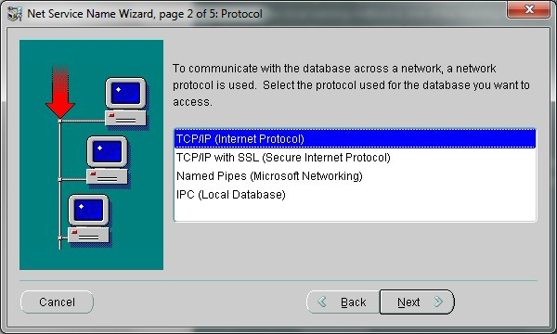

Input the server IP & Port
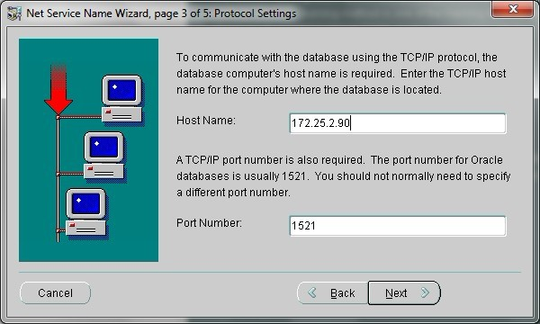
Service Name “ORCL” , Connection Type choose “Database Default”
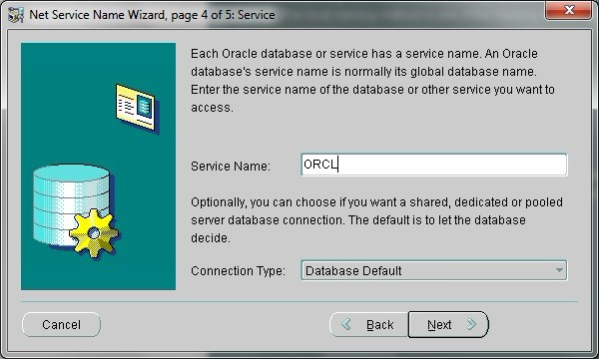

Done
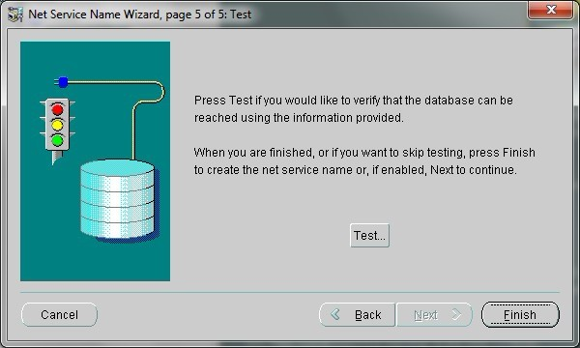

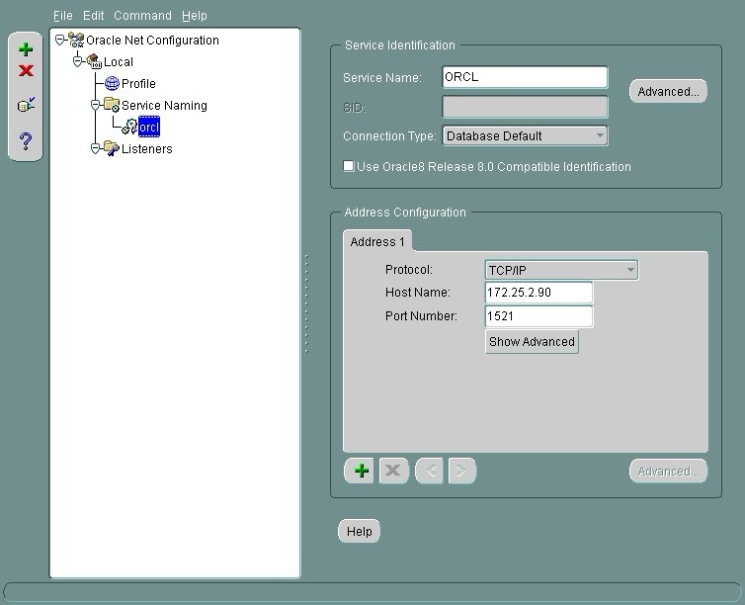

Set The Connection In “ODBC” in
Windows -> Admin Panel -> Administrative Tools -> Data Sources(ODBC)
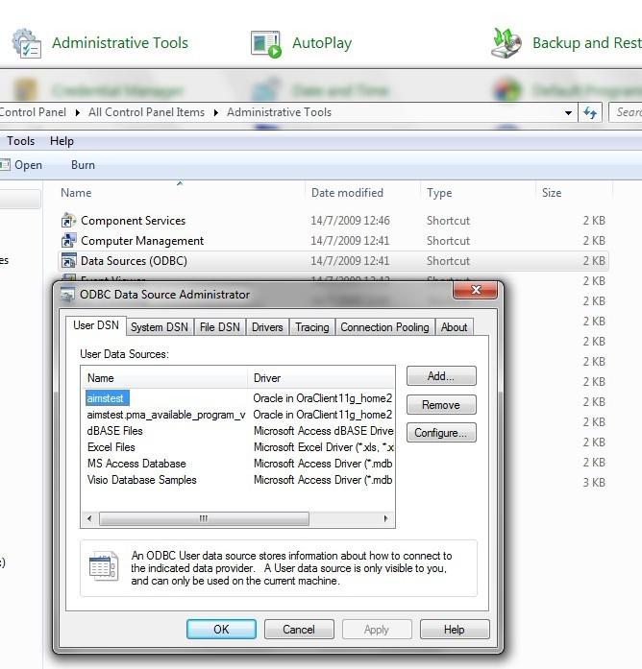
Click “Add” -> Select “Oracle in OraClient 11g_home2”
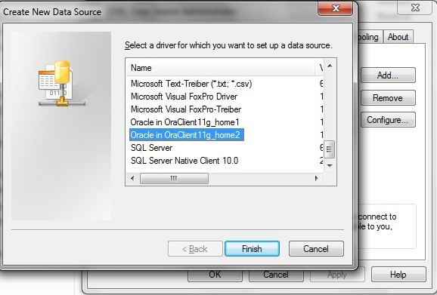

TNS Service Name choose “ORCL” , User ID is oracle username then OK
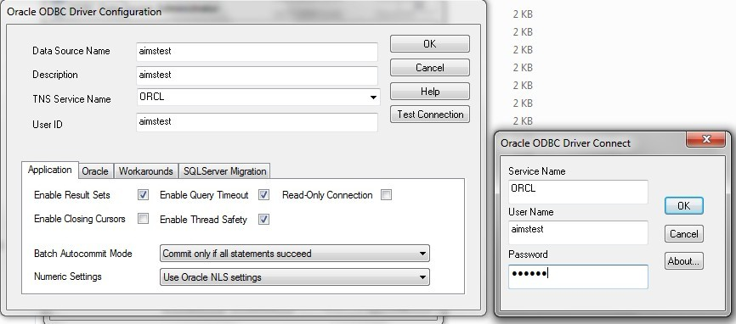
Other Method

or you can use Oracle instant client
http://www.oracle.com/technetwork/database/features/instant-client/index-097480.html

Download 2 files
1. Instant Client Package - Basic: All files required to run OCI, OCCI, and JDBC-OCI applications
instantclient-basic-nt-11.2.0.3.0.zip (51,149,941 bytes)
2. *Instant Client Package - ODBC: Additional libraries for enabling ODBC applications
instantclient-odbc-nt-11.2.0.3.0.zip (740,177 bytes)
Then Unzip 2 file into same folder C:\oracle

Set environment path :
TNS_ADMIN=c:\oracle
Path=c:\oracle
SQLPATH=c:\oracle
ORACLE_HOME=c:\oracle
LD_LIBRARY_PATH=c:\oracle
NLS_LANG=TRADITIONAL CHINESE_TAIWAN.ZHT16BIG5
ORACLE_HOME=c:\oracle
SQLPATH=c:\oracle

new a file “tnsnames.ora” in C:\oracle and edit it below

ORCL =
(DESCRIPTION =
(ADDRESS = (PROTOCOL = TCP)(HOST = your server ip)(PORT = service port))
(CONNECT_DATA =
(SERVER = DEDICATED)
(SERVICE_NAME = ORCL)
)
)

Set The Connection In “ODBC” please see Page.34
- Add Excel Pivot Table

Open a new file -> “資料” -> “樞紐分析表及圖報表”
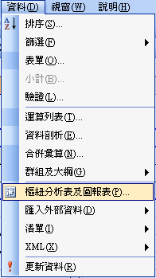

Choose “外部資料庫” -> Click “下一步”
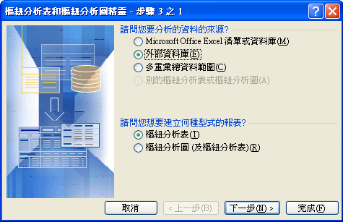
Choose “取得資料”
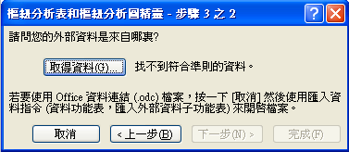

In there you will see a DB you add before, select “aimstest” -> click “確定”
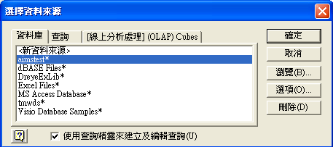

Input Password
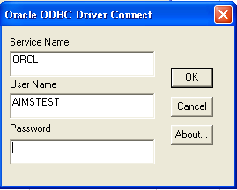
Select which table you want to add
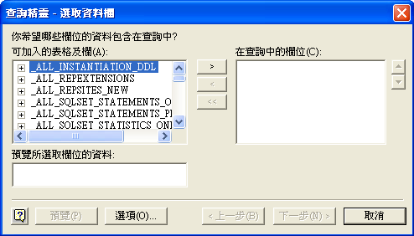
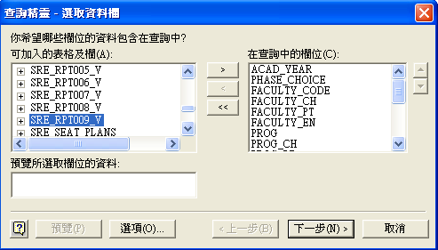
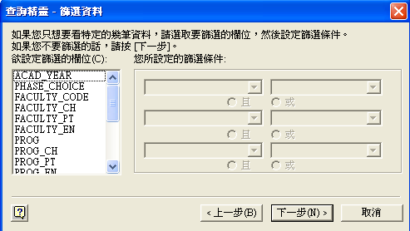
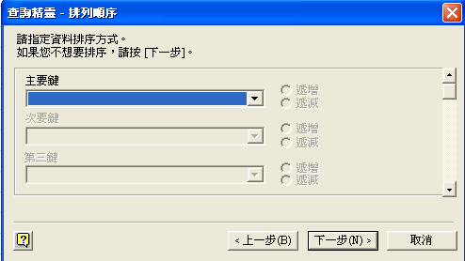
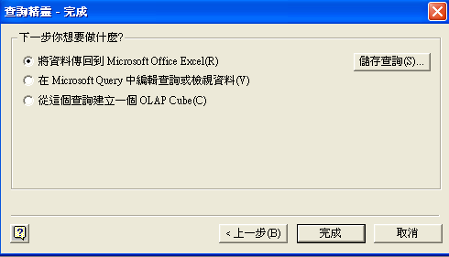
Click “完成”
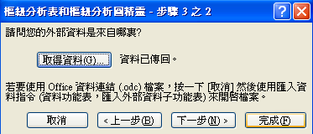

Finish ! now you can edit your pivot table what you want
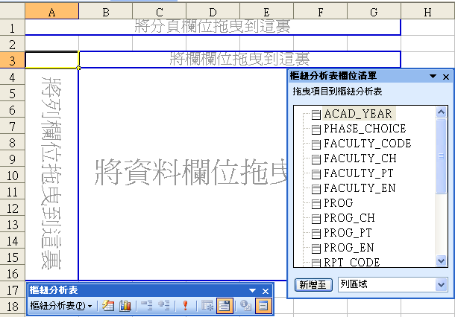
- Disable "export menu" option

I. Edit file " \webapps\jasperserver\WEB-INF\flows\viewReportBeans.xml"
II. Find "<util:map id="exporterConfigMap">"
III. You will see the output option then <!-- --> it.
IV. Restart JasperServer
- Backup & Restore File

I. Backup
Go to the command prompt and find the path of Buildomatic directory in Jasper Server.
1: If you want to take the whole Jasper server repository backup
<js-install directory>buildomatic>js-export.bat --everything --output-zip backup.zip
2: If you want to take the backup of any specific directory
<js-install directory>buildomatic>js-export.bat --output-zip backup.zip --uris /Resource_id_of_directory

II. Restore
Go to the command prompt and find the path of Buildomatic directory in Jasper Server.
<js-install directory>buildomatic>js-import.bat --input-zip backup.zip

It will create the whole Jasper server repository on your Jasper serve, but if the directories are already existing it will not update those directory, so delete the directory from jasper server and run the import command.
- Change the output date format

Google Chrome : Option -> Setting
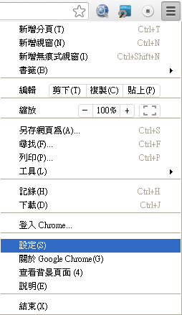

Click “顯示進階設定”


Click “語言和輸入設定”

Move up “英文” to the top then save. Done !
